Naming polygons
A polygon is a plane figure bounded by line segments.
Polygons are named using the number of sides they possess.

Number  of sides | Name of  polygon | Examples
3 | triangle | 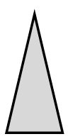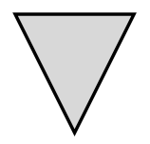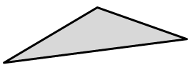
4 | quadrilateral | 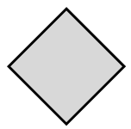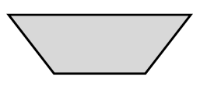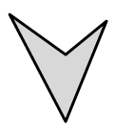
5 | pentagon | 
6 | hexagon | 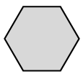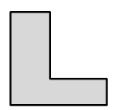
8 | octagon | 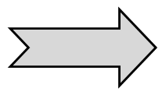
10 | decagon | 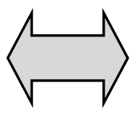
12 | dodecagon | 

The Sum of the Interior Angles of a Polygon

A polygon is a plane figure bounded by line segments.
There is a pattern for calculating the sum of the interior angles.
Explore: http://illuminations.nctm.org/ActivityDetail.aspx?ID=9
http://www.mathopenref.com/polygoninteriorangles.html

Number  of sides | Name of  polygon | The angle sum of a polygon is the  sum of the interior angles. | Short Cut
3 | triangle | a + b + c = 180 | Start with  3 sides,  subtract 2  then multiply by 180
4 | quadrilateral | a + b + c + d = 360 | Start with  4 sides,  subtract 2  then multiply by 180
5 | pentagon | a + b + c + d + e = 540 | Start with  5 sides,  subtract 2  then multiply by 180
6 | hexagon | Look at the pattern above: 180, 360, 540, ........  Therefore a + b + c + d + e + f = 720 | Start with  6 sides,  subtract 2  then multiply by 180
8 | octagon | (8 - 2) x 180 = 1080  The interior angle sum of every octagon is 1080 degrees.
10 | decagon | (10 - 2) x 180 = 1440  The interior angle sum of every decagon is 1440 degrees
12 | dodecagon | (12 - 2) x 180 = 1800 degrees  The interior angle sum of every dodecagon is 1800 degrees
20 | icosagon | (20 - 2) x 180 = 3240 degrees  The interior angle sum of every icosagon is 3240 degrees

The Sum of the Exterior Angles of a Polygon

A polygon is a plane figure bounded by line segments.
Sometimes the sides are extended to form exterior angles.
Explore: http://www.ies.co.jp/math/java/samples/gaikaku.html
http://www.mathopenref.com/polygonexteriorangles.html

Number  of sides | Name of  polygon | What is the sum of the exterior angles?
3 | triangle | a + b + c = 360 degrees
4 | quadrilateral | a + b + c + d = 360 degrees
5 | pentagon | a + b + c + d + e = 360 degrees
6 | hexagon | a + b + c + d + e + f = 360 degrees
8 | octagon | 360 degrees
10 | decagon | 360 degrees
12 | dodecagon | 360 degrees
20 | icosagon | 360 degrees

Regular polygons  A polygon is regular if all sides have equal length and all interior angles are equal. | Irregular polygons
Regular triangles are called equilateral triangles.  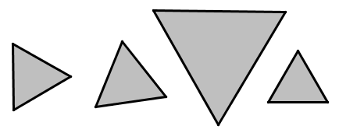 | These triangles are irregular  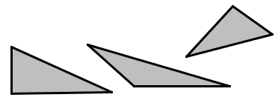
Every regular quadrilateral is a square.   | Every rhombus has equal sides but not equal angles.    Every rectangle has equal angles but not equal sides.  
This is a regular pentagon | These pentagons are irregular
These are regular hexagons   | These hexagons are irregular  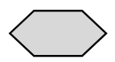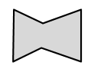
This is a regular octagon | These octagons are irregular  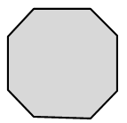

Angles in Regular Polygons

A polygon is regular if all sides have equal length and all interior angles are equal.

Number  of sides | Name of  regular polygon | How many degrees in each  of the interior angles? | How many degrees in each  of the exterior angles?
3 | equilateral  triangle | a = b = c = 60 degrees | $360÷3=120$ degrees
4 | square | a = b = c = d = 90 degrees | $360÷4=90$ degrees
5 | regular  pentagon | a = b = c = d = e = 108 degrees | $360÷5=72$ degrees
6 | regular  hexagon | The exterior angles are all $360÷6=60$ degrees  Therefore, the interior angles are all $180-60=120$ degrees
8 | regular  octagon | The exterior angles are all $360÷8=45$ degrees  Therefore, the interior angles are all$180-45=135$ degrees
10 | regular  decagon | The exterior angles are all $360÷10=36$ degrees  Therefore, the interior angles are all$180-36=144$ degrees
12 | regular  dodecagon | The exterior angles are all $360÷12=30$ degrees  Therefore, the interior angles are all$180-30=150$ degrees
20 | regular  icosagon | The exterior angles are all $360÷20=18$ degrees  Therefore, the interior angles are all$180-18=162$ degrees

Convex polygons  A polygon is convex if all the interior angles are less than 180 degrees. | Non-convex polygons  If one or more of the interior angles is more than 180 degrees the polygon is non-convex (or concave).
All triangles are convex | It is not possible to draw a non-convex triangle.
These quadrilaterals are convex | This quadrilateral is non-convex.  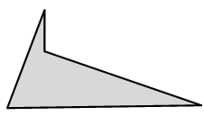  This is a non-convex kite 
These pentagons are convex | These pentagons are non-convex  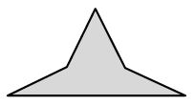
These hexagons are convex | These hexagons are non-convex

Tangram Challenge 1
Find all of the 13 different convex polygons that can be made using all 7 pieces of a tangram.
Hint: 4 of them are hexagons, 2 are pentagons, 6 are quadrilaterals and 1 is a triangle.

Tangram Challenge 2
Now use all 7 pieces to make at least 20 different non-convex hexagons.
Here is an example that is possible to make:

Classifying Triangles
Triangles may be classified using their sides and their angles.
There are 7 different types of triangles.

 |  | Classifying triangles using their angles
 |  | Acute-angled triangles contain 3 angles less than 90 degrees | Right-angled triangles contain one 90 degree angle | Obtuse-angled triangles contain one angle more than 90 degrees
Classifying triangles using their sides | Equilateral triangles | 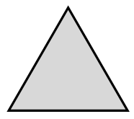 | Not possible | Not possible
Classifying triangles using their sides | Isosceles triangles | 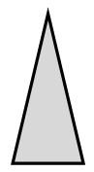 | 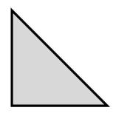 | 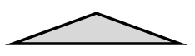
Classifying triangles using their sides | Scalene triangles | 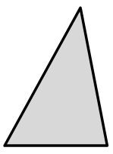 | 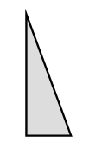 | 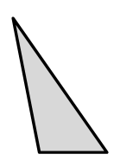

A quadrilateral is a polygon bounded by 4 line segments.

Special quadrilaterals | Examples
A trapezium is a quadrilateral with one pair of sides parallel.
A kite is a quadrilateral with two pairs of adjacent sides equal.
A parallelogram is a quadrilateral whose opposite sides are parallel.
A rhombus is a quadrilateral with all sides equal.
A rectangle is a quadrilateral in which all angles are right angles.
A square is a quadrilateral that is both a rectangle and a rhombus.

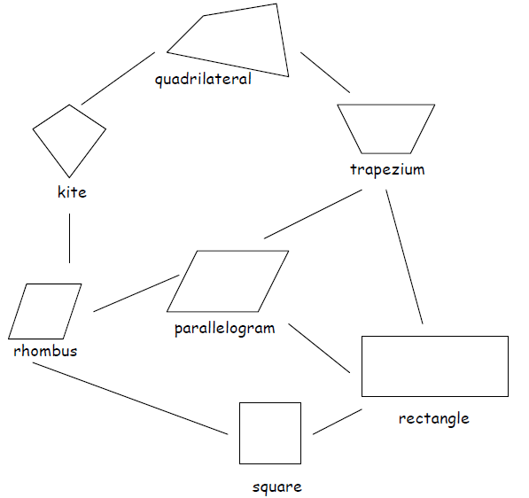

Trapezia

A trapezium is a quadrilateral with at least one pair of sides parallel.

Here are some examples of trapezia
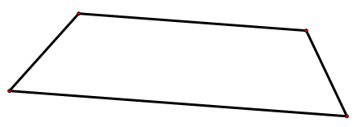 | 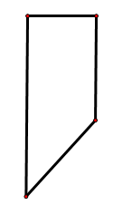 | 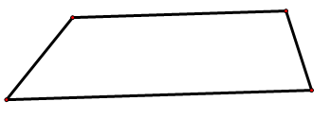

All trapezia possess the following property: One pair of sides of a trapezium are parallel

This trapezium is usually called a rhombus  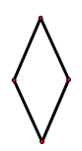 | This trapezium is usually called a parallelogram  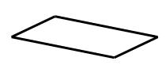
This trapezium is usually called a square  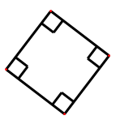 | This trapezium is usually called a rectangle  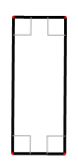

Challenge 1: Draw a trapezium with exactly 1 pair of parallel sides and exactly 2 equal sides.
Challenge 2: Draw a trapezium with exactly 1 pair of parallel sides and exactly 3 equal sides.
Challenge 3: Draw a trapezium with exactly 4 equal sides.

Kites

A kite is a quadrilateral with two pairs of adjacent sides equal.
Here are some examples of kites:
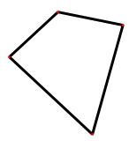 | 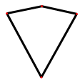 | 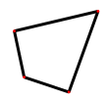

All kites possess the following properties:
• Two pairs of adjacent sides of a kite are equal
• One diagonal of a kite bisects the other diagonal
• One diagonal of a kite bisects the opposite angles
• The diagonals of a kite are perpendicular
• A kite has at least one axis of symmetry

This kite is usually called a rhombus | This kite is usually called a square

Parallelograms

A parallelogram is a quadrilateral whose opposite sides are parallel.

Here are some examples of parallelograms:
All parallelograms possess the following properties:
• The opposite sides of a parallelogram are parallel
• The opposite sides of a parallelogram are equal
• The opposite angles of a parallelogram are equal
• The diagonals of a parallelogram bisect each other
• A parallelogram has point symmetry and rotational symmetry

This parallelogram is usually called a rhombus | This parallelogram is usually called a rectangle
This parallelogram is usually called a square | I am a quadrilateral. I am also a trapezium.  My best name is a parallelogram

Rhombuses

A rhombus is a quadrilateral with all sides equal.
Here are some examples of rhombuses:
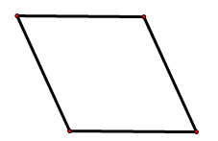 | 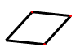

All rhombuses possess the following properties:
• The opposite sides of a rhombus are parallel
• All sides of a rhombus are equal
• The opposite angles of a rhombus are equal
• The diagonals of a rhombus bisect the opposite angles
• The diagonals of a rhombus bisect each other
• The diagonals of a rhombus are perpendicular
• A rhombus has two axes of symmetry
• A rhombus has point symmetry and rotational symmetry

This rhombus is usually called a square | I am a quadrilateral. I am also a kite, a trapezium and a parallelogram. My best name is a rhombus.

Rectangles

A rectangle is a quadrilateral in which all angles are right angles.

Here are some examples of rectangles:
 | 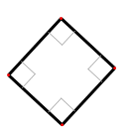 |  | 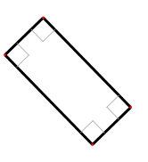

All rectangles possess the following properties:
• The opposite sides of a rectangle are parallel
• The opposite sides of a rectangle are equal
• All angles at the vertices of a rectangle are 90º
• The diagonals of a rectangle are equal
• The diagonals of a rectangle bisect each other
• A rectangle has two axes of symmetry
• A rectangle has point symmetry and rotational symmetry

This rectangle is usually called a square | I am a quadrilateral. I am also a trapezium and a parallelogram. My best name is a rectangle.

Squares

A square is a quadrilateral that is both a rectangle and a rhombus.
Here are some examples of squares:
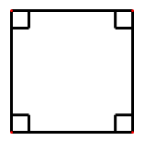

All squares possess the following properties:
• Opposite sides of a square are parallel
• All sides of a square are equal
• All angles at the vertices of a square are 90º
• The diagonals of a square are equal
• The diagonals of a square bisect the opposite angles
• The diagonals of a square bisect each other
• The diagonals of a square are perpendicular
• A square has four axes of symmetry
• A square has point symmetry and rotational symmetry

I am a quadrilateral. I am also a kite, a trapezium, a rhombus, a parallelogram and a rectangle.
My best name is a square.

